ISSB Individual Obstacles, Photos and Complete Guide
ISSB Individual Obstacles are the hot topic among the candidates who are going for ISSB. It is considered to be the toughest part of ISSB as many candidates are not aware of nor they are physically so good as a sportsman. For best ISSB Preparation, you must get know-how of these obstacles and how these are completed.

ISSB Individual Obstacles Introduction
ISSB Individual Obstacles are 9 different hurdles in the ground which a candidate has to pass in 2 minutes. These hurdles are of different types which will utilize the energy and capability of all your body muscles. The usage of almost all body muscles is used in ISSB Individual Obstacle. Before performing the ISSB Individual Obstacles the GTO shows a video to the candidate on the multimedia that how to pass each hurdle in the right way. So before performing, you are given an exact idea of the situation visually.
There are only 2 minute’s times for these 9 ISSB Individual Obstacle. Most of the cases candidates are not able to complete all the 9 obstacles and they reach up to 6 or 7 hurdles when the time is ended.

ISSB Individual Obstacle List
- Hanging Bridge
- Hanging Tyre
- High Jump
- Long Jump
- Monkey bridge
- Multi-Down Up
- Rope Climbing
- Tarzan Swing
- Zig-Zag

ISSB Individual Obstacle Tips
Here are few tips for ISSB individual obstacles.
- Choose the easy obstacle first so that you can save your time.
- If the GTO asks you to complete any hurdle you have to follow his order.
- It doesn’t matter if you are not able to complete all the hurdles in ISSB Individual Obstacles.
- Basically, your willpower, control on fear and stamina is checked in this task.
- It is also focused that if there is a difficult hurdle is the candidate willing to do it or not.
- Rashid Minhas was able to complete only 1 hurdle and Hafeez Bhatti scores a record of completing all the 9 hurdles twice in 2 minutes. So you can see that it doesn’t matter how much you pass, just show your maximum input.
- You can repeat the obstacle to improve your grading but this can only be done when you have completed all the 9 hurdles.
- Take care of yourself while performing obstacles to avoid any injury.

ISSB Individual Obstacle Photos
Here are the photos of all of 9 ISSB Individual Obstacle.
ISSB Hanging Bridge Obstacle
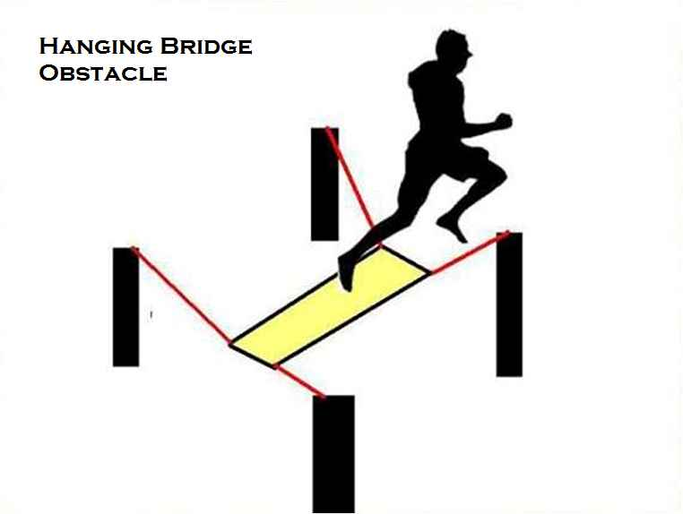
ISSB Hanging Tyre Obstacle
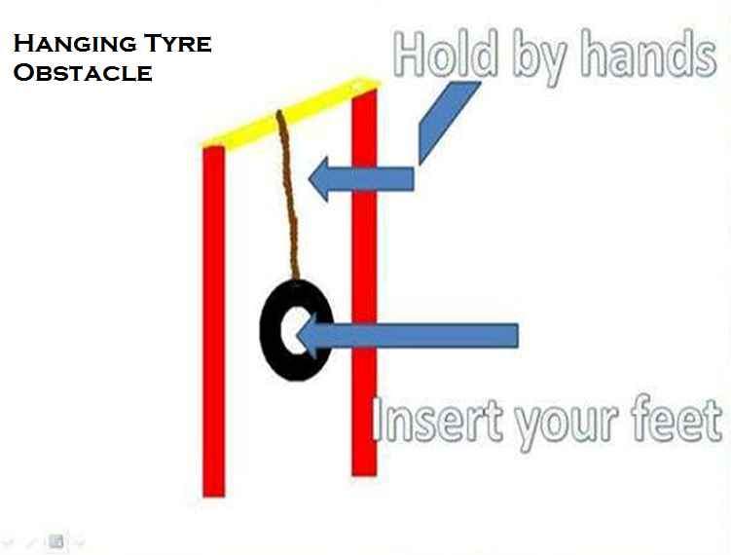

ISSB High Jump Obstacle
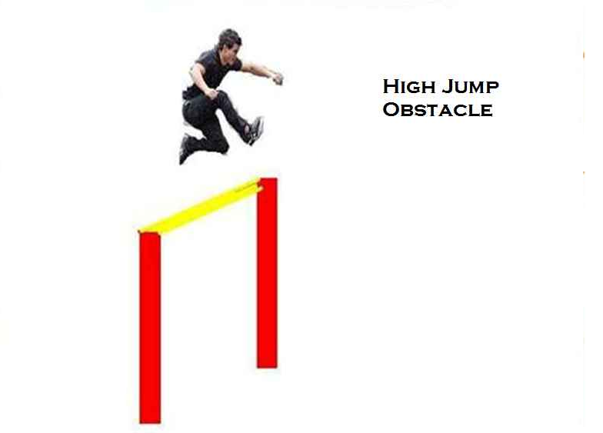

ISSB Long Jump Obstacle
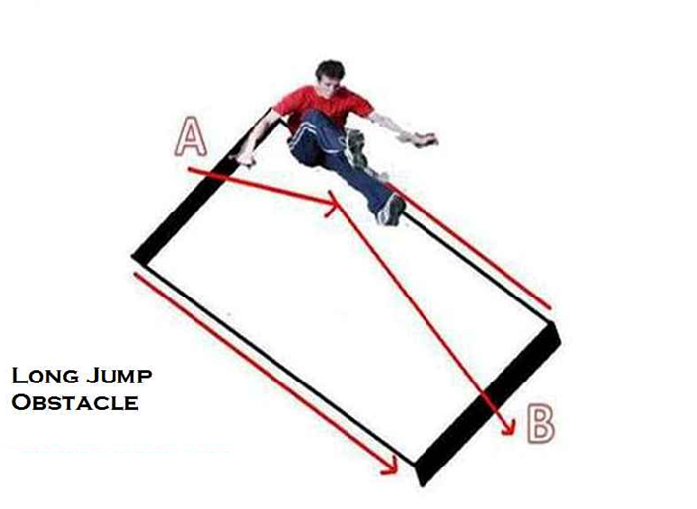

ISSB Monkey Bridge Obstacle
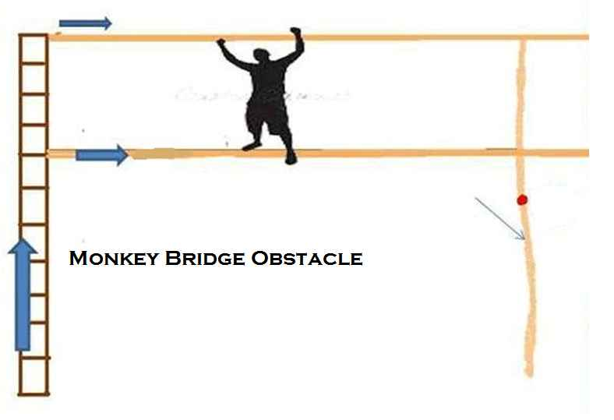

ISSB Multi-Down Up Obstacle

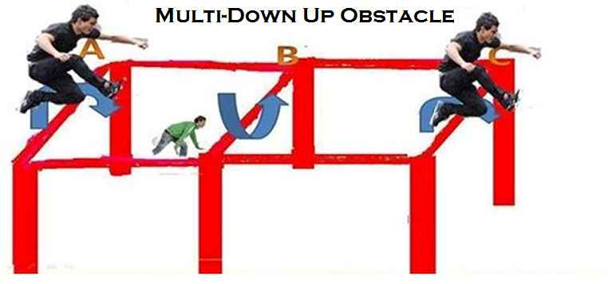

ISSB Rope Climbing Obstacle

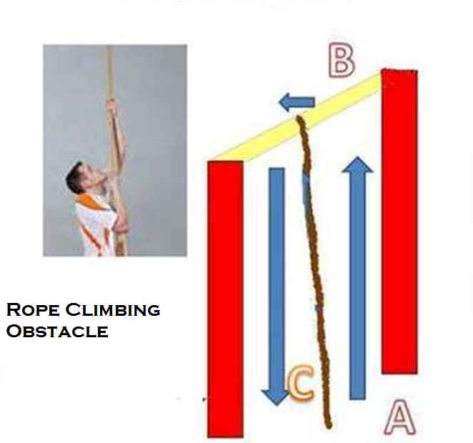

ISSB Tarzan Swing Obstacle

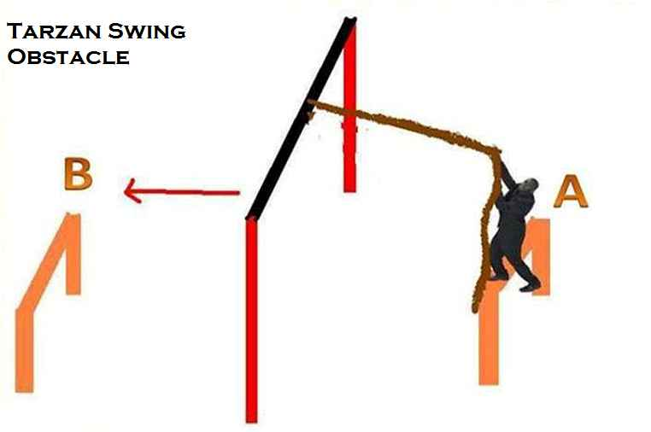

ISSB Zig Zag Obstacle

